**PYTHON PROJECT**

**FLASK FRAMEWORK**

**1. PROJECT TITLE:-**

Creating a Student Management System Project Using Flask Framework Flask Module in Python Using In PyCharm Platform.

**2. PROJECT DESCRIPTION:-**

In This Project Create a Website of Student Management System that Contains Students Data. In this Website Contains Create (Adding) of Student Details, Editing of Student Details, Deleting of Students details Options to connect to Student Management System Database. In This Project Created website entering all Data is stored In Database and Its Retrieving from Database to Website. In This Project Connecting Python with MySQL Database.

**3. CODING:-**

**Process for New Project:-**



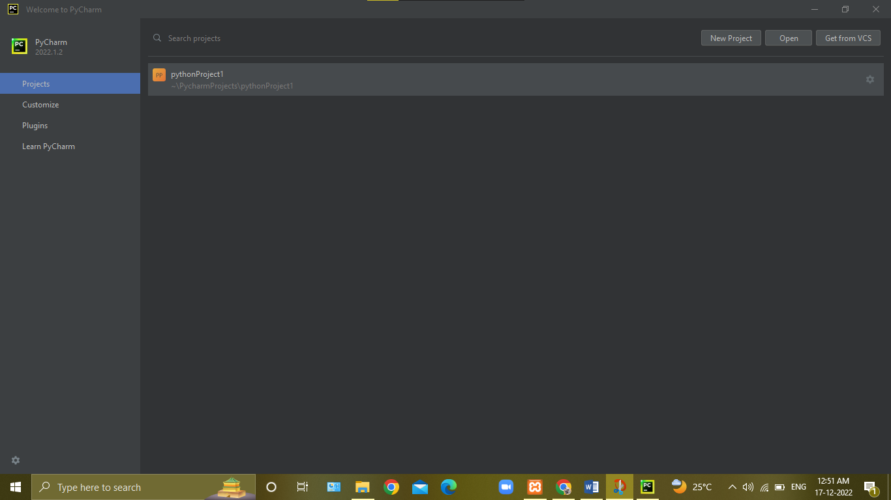

**Click To New Project**

**Enter New Project Name**

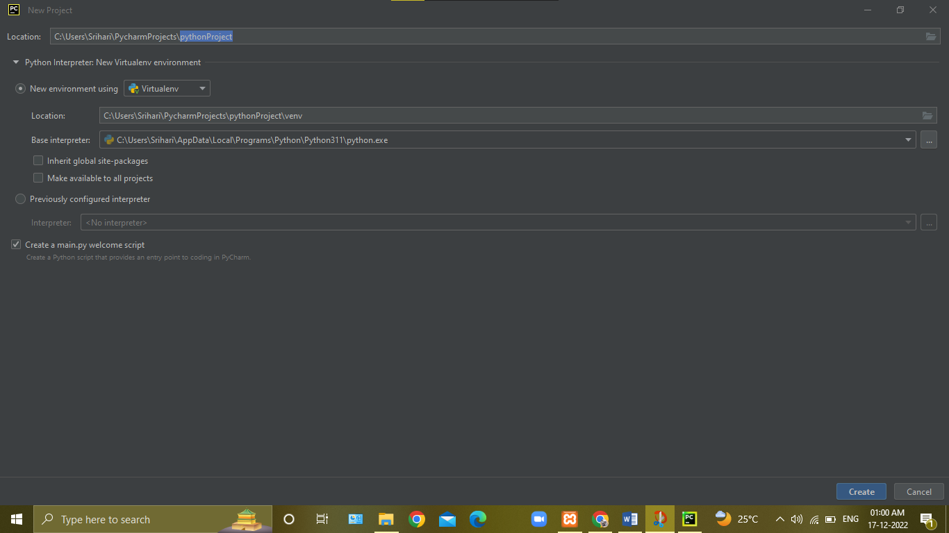

**Click To Create New Project**

**Click to Create Virtual Environment**

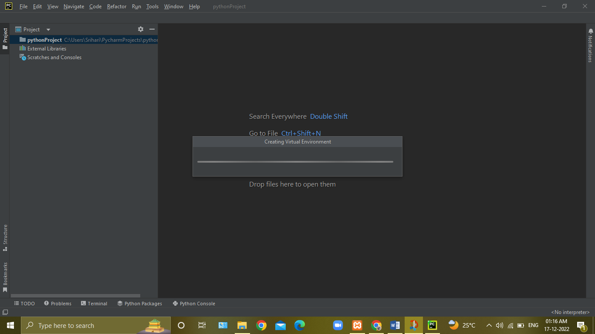

**Creating of Venv**

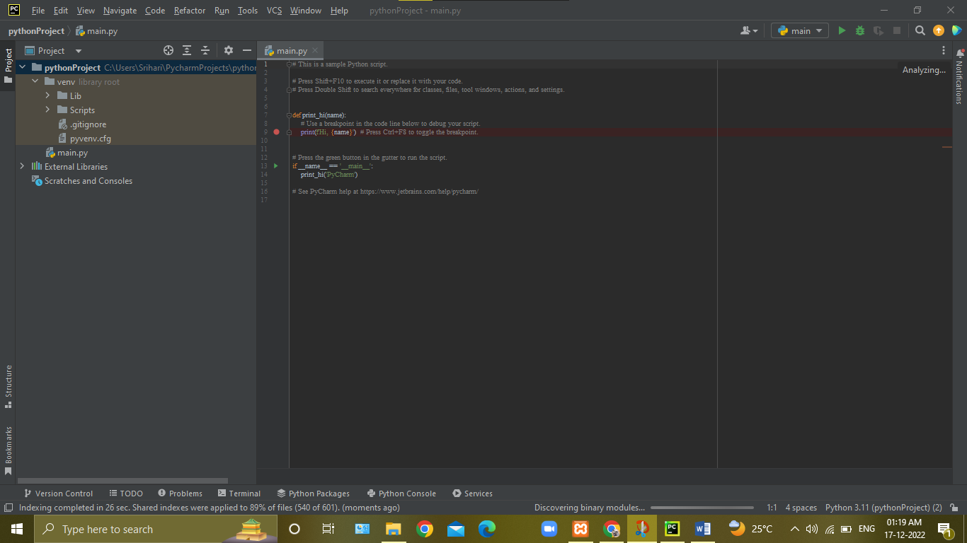

**Pycharm Work Area**

**Installation of Modules:-**

In PyCharm>>>Go to **Files** click**>>>** Go to **Settings** click>>> Go to **Project:pythonProject** click>>**>**select **Python Interpreter** click**>>>** click **‘+’** button>>**>** Search **flask, pymysql>>>**click **install>>>**click **ok**

**Click to Files**

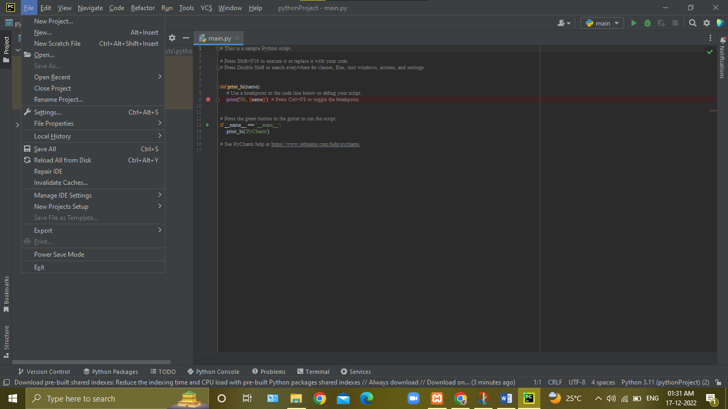

**Click to Settings**

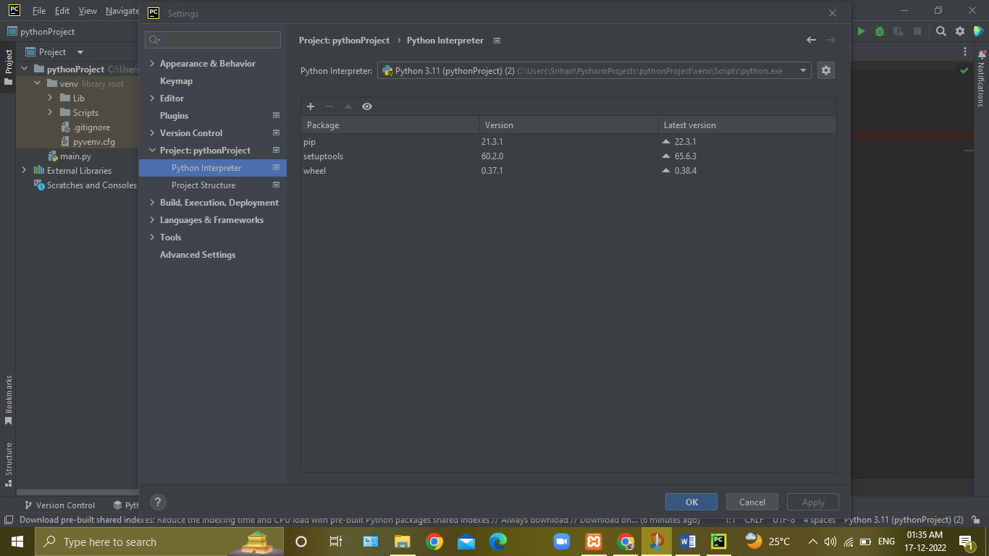

**Click to ‘+’ button**

**Search Flask and Pymysql Modules**

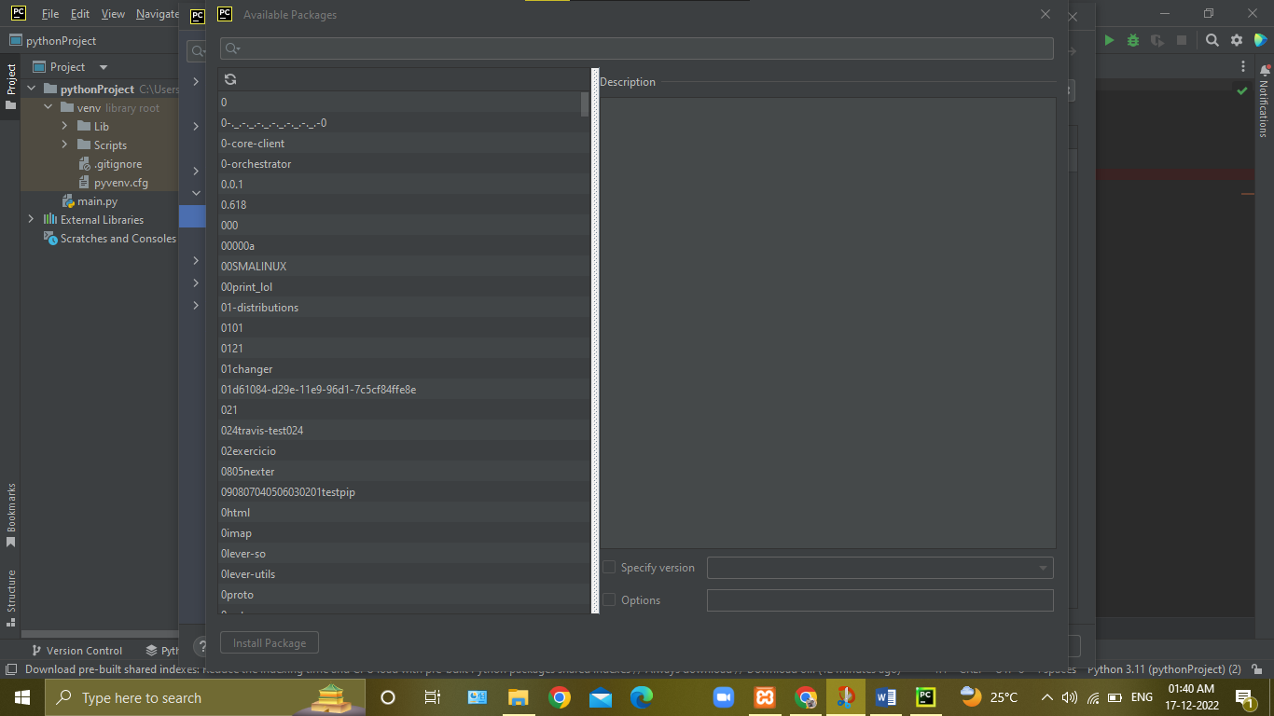

**Click to Install Package**

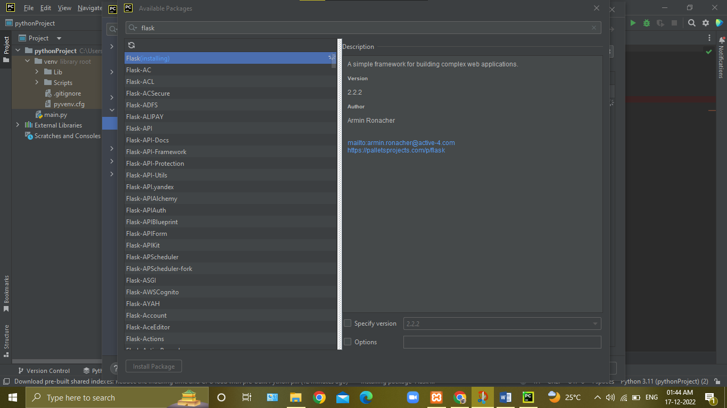

**Installing Flask Module**

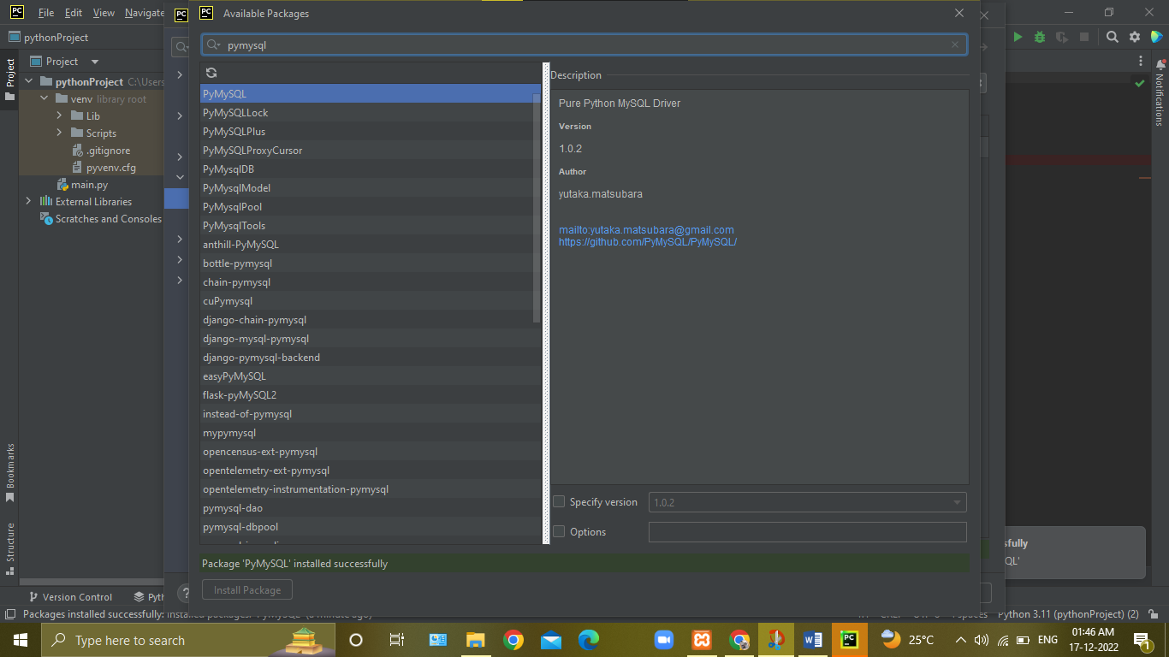

**Inistalling Pymysql Module**

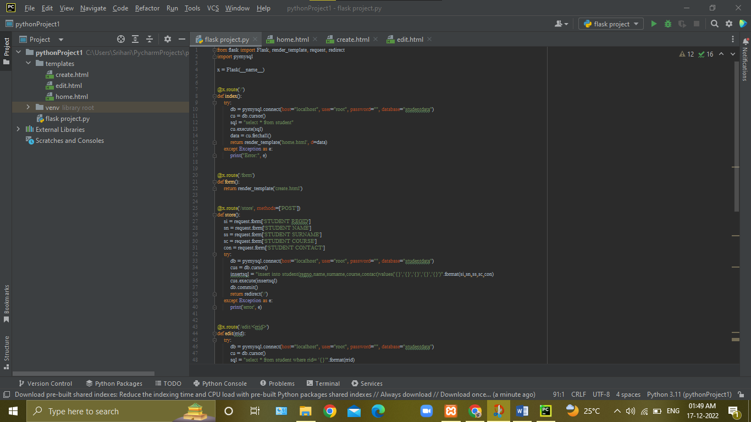

**Python Executing File**

**Create templates folder Create forms in templates**

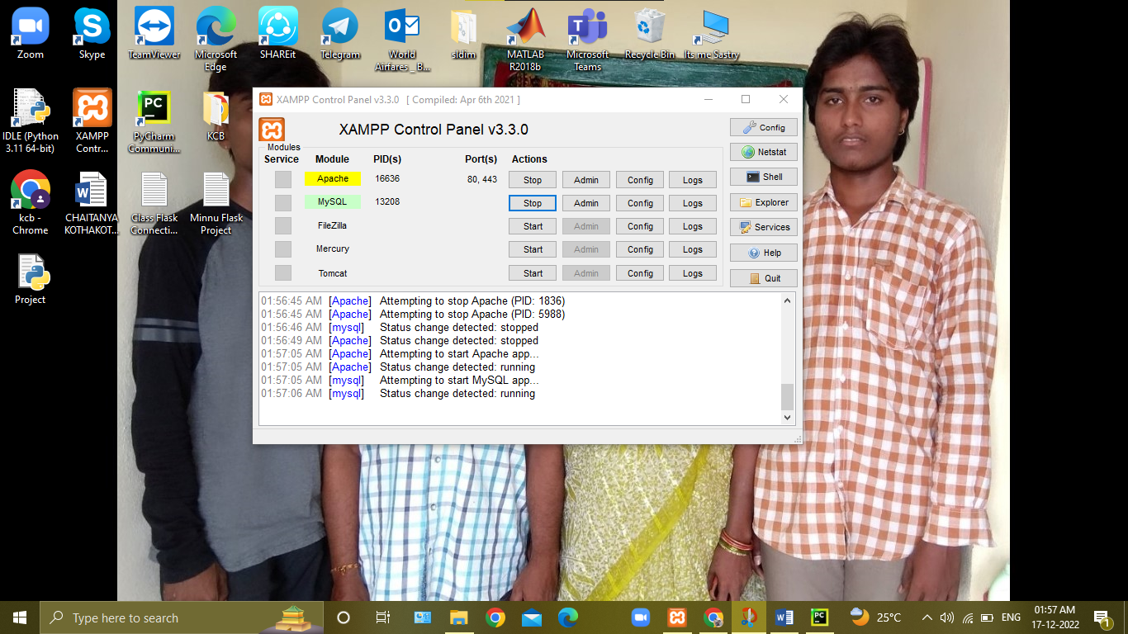

**Start Apache, MySQL**

**Search localhost**

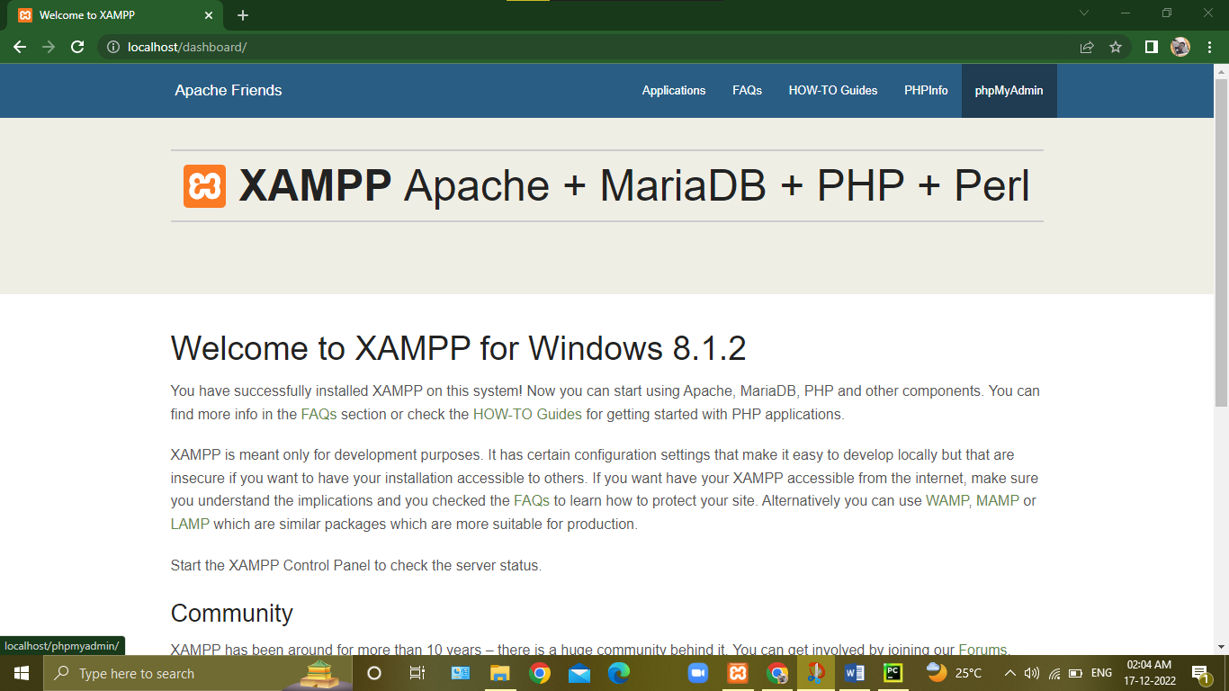

**Click phpMyAdmin**

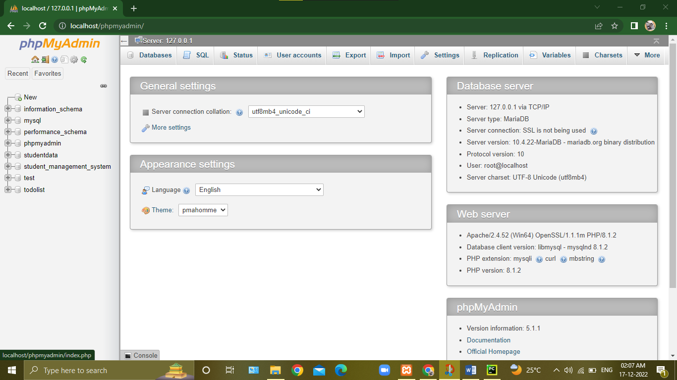

**Click New for Creating New Database**

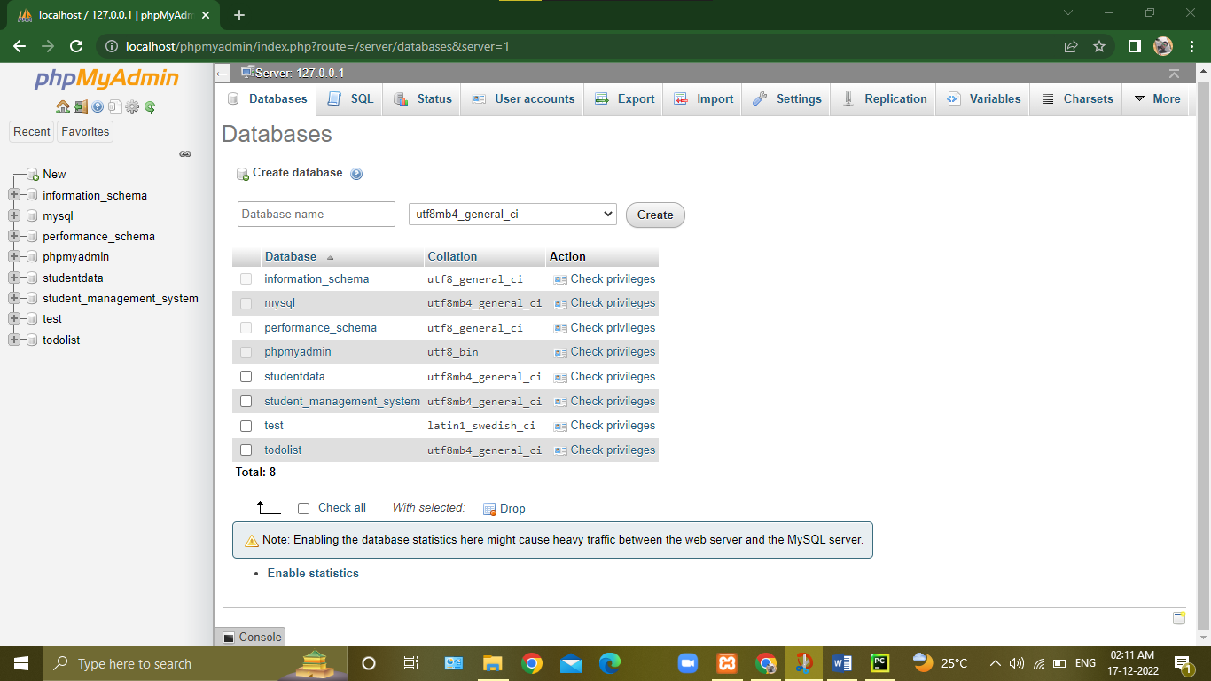

**Enter Database Name**

**Click Create For Database Creation**

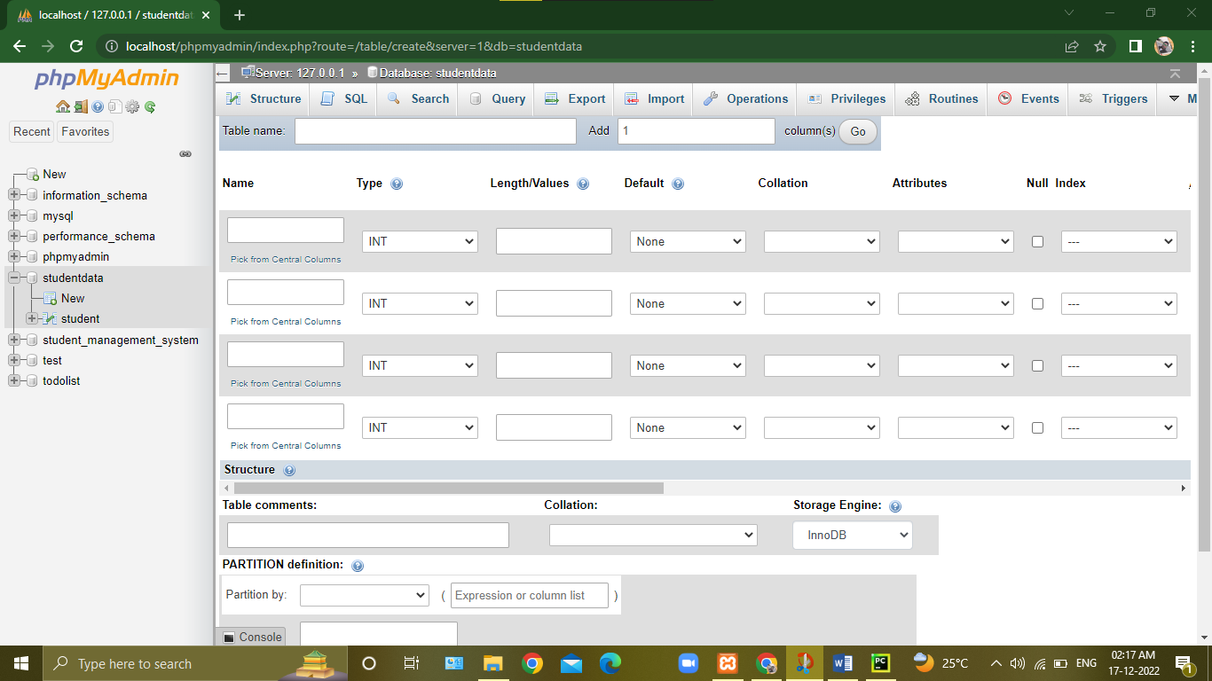

**Click New For Table Creation**

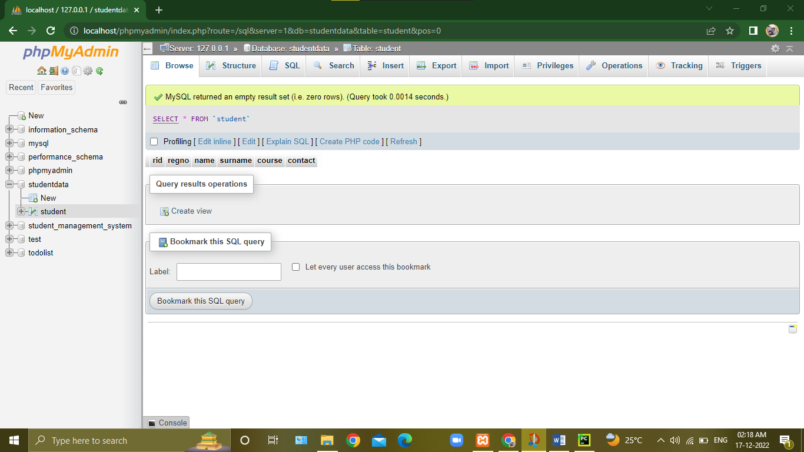

**After Table Creation**

**PROGRAM:-**

from flask import Flask, render_template, request, redirect

import pymysql

x = Flask(__name__)

@x.route('/')

def index():

try:

db = pymysql.connect(host="localhost", user="root", password="", database="studentdata")

cu = db.cursor()

sql = "select * from student"

cu.execute(sql)

data = cu.fetchall()

return render_template('home.html', d=data)

except Exception as e:

print("Error:", e)

@x.route('/form')

def form():

return render_template('create.html')

@x.route('/store', methods=['POST'])

def store():

si = request.form['STUDENT REGID']

sn = request.form['STUDENT NAME']

ss = request.form['STUDENT SURNAME']

sc = request.form['STUDENT COURSE']

con = request.form['STUDENT CONTACT']

try:

db = pymysql.connect(host="localhost", user="root", password="", database="studentdata")

cus = db.cursor()

insertsql = "insert into student(regno,name,surname,course,contact)values('{}','{}','{}','{}','{}')".format(si,sn,ss,sc,con)

cus.execute(insertsql)

db.commit()

return redirect('/')

except Exception as e:

print('error', e)

@x.route('/edit/<rrid>')

def edit(rrid):

try:

db = pymysql.connect(host="localhost", user="root", password="", database="studentdata")

cu = db.cursor()

sql = "select * from student where rid= '{}'".format(rrid)

cu.execute(sql)

data = cu.fetchone()

return render_template('edit.html', d=data)

except Exception as e:

print("Error:", e)

@x.route('/update/<rrid>', methods=['GET','POST'])

def update(rrid):

si = request.form['STUDENT REGID']

sn = request.form['STUDENT NAME']

ss = request.form['STUDENT SURNAME']

sc = request.form['STUDENT COURSE']

con = request.form['STUDENT CONTACT']

try:

db = pymysql.connect(host="localhost", user="root", password="", database="studentdata")

cu = db.cursor()

sql = "update student SET regno='{}',name='{}',surname='{}',course='{}',contact='{}' where rid='{}'".format(si,sn,ss,sc,con,rrid)

cu.execute(sql)

db.commit()

return redirect('/')

except Exception as e:

print("Error:", e)

@x.route('/delete/<rrid>')

def delete(rrid):

try:

db = pymysql.connect(host="localhost", user="root", password="", database="studentdata")

cu = db.cursor()

sql = "delete from student where rid={}".format(rrid)

cu.execute(sql)

db.commit()

return redirect('/')

except Exception as e:

print("Error:", e)

if __name__=='__main__':

x.run(debug=True)

**4. INPUT:-**

**a). CREATE FORM-1: HOME PAGE**

**Program:-**

<html>

<head>

<title>Home Page</title>

</head>

<body>

<br><h1 align="center">STUDENT MANAGEMENT SYSTEM</h1><br>

<table border="5" align="center">

<tr>

<th>| STUDENT REGID |</th>

<th>| STUDENT NAME |</th>

<th>| STUDENT SURNAME |</th>

<th>| STUDENT COURSE |</th>

<th>| STUDENT CONTACT |</th>

<th>| EDIT |</th>

<th>| DELETE |</th>

</tr>

{%for x in d: %}

<tr>

<td align="center">{{x.1}}</td>

<td align="center">{{x.2}}</td>

<td align="center">{{x.3}}</td>

<td align="center">{{x.4}}</td>

<td align="center">{{x.5}}</td>

<td align="center"><a href="/edit/{{x.0}}"> <button>Edit</button> </a></td>

<td align="center"><a href="/delete/{{x.0}}"> <button>Delete</button> </a></td>

</tr>

{% endfor %}

</table>

<h2 align="center">

<a href="/form"><button>Create</button></a>

</h2>

</body>

</html>

**Output:-**

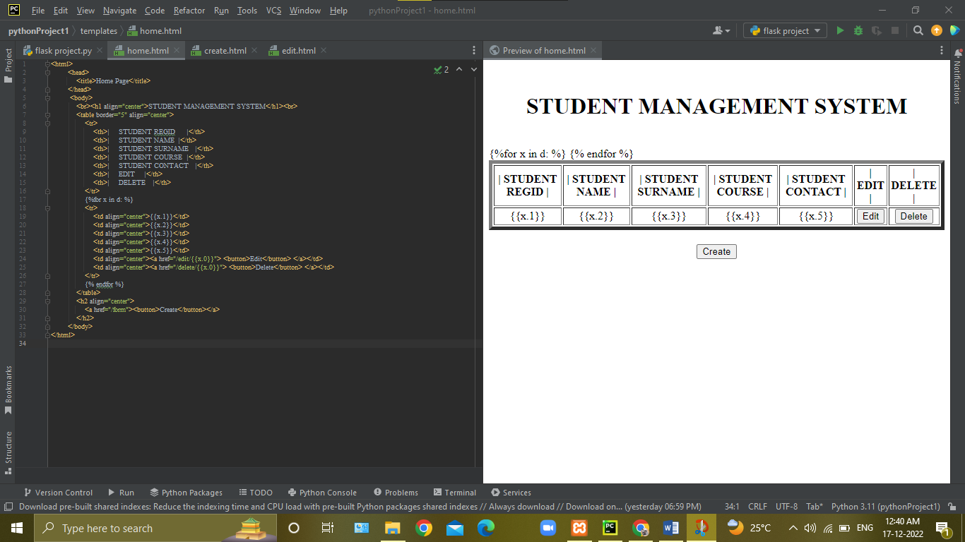

**b). CREATE FORM-2: CREATE**

**Program:-**

<html>

<head>

<title>create</title>

</head>

<body>

<br><br>

<h1 align="center">CREATE DATA</h1>

<form action="/store" method="POST">

<table border="5" align="center">

<tr align="center"><td align="center">STUDENT REGID</td><td><input type="text" name="STUDENT REGID" value=" "></td></tr>

<tr align="center"><td align="center">STUDENT NAME</td><td><input type="text" name="STUDENT NAME" value=" "></td></tr>

<tr align="center"><td align="center">STUDENT SURNAME</td><td><input type="text" name="STUDENT SURNAME" value=" "></td></tr>

<tr align="center"><td align="center">STUDENT COURSE</td><td><input type="text" name="STUDENT COURSE" value=" "></td></tr>

<tr align="center"><td align="center">STUDENT CONTACT</td><td><input type="text" name="STUDENT CONTACT" value=" "></td></tr>

</table>

<h2 align="center">

<a href="/form"><button>Insert</button></a>

</h2>

</form>

</body>

</html>

**Output:-**

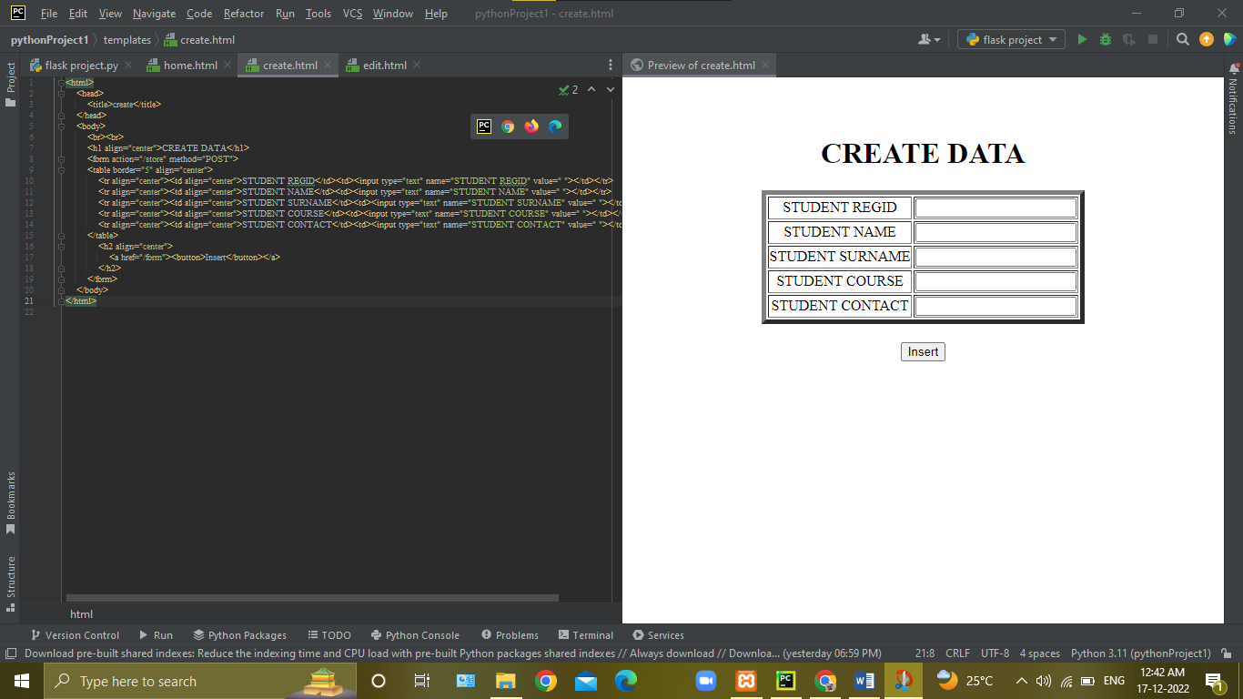

**c). CREATE FORM-3: EDIT/UPDATE**

**Program:-**

<html>

<head>

<title>edit/update</title>

</head>

<body>

<br><br>

<h1 align="center">EDIT/UPDATE DATA</h1>

<form action="/update/{{d.0}}" method="POST">

<table border="5" align="center">

<tr align="center"><td align="center">STUDENT REGID :</td>

<td><input type="text" name="title" value="{{d.1}}"/></td></tr>

<tr align="center"><td align="center">STUDENT NAME :</td>

<td><input type="text" name="detail" value="{{d.2}}"/></td></tr>

<tr align="center"><td align="center">STUDENT SURNAME :</td>

<td><input type="text" name="date" value="{{d.3}}"/></td></tr>

<tr align="center"><td align="center">STUDENT COURSE :</td>

<td><input type="text" name="date" value="{{d.4}}"/></td></tr>

<tr align="center"><td align="center">STUDENT CONTACT :</td>

<td><input type="text" name="date" value="{{d.5}}"/></td></tr>

</table>

<h2 align="center">

<a href="/form"><button>Edit/Update</button></a>

</h2>

</form>

</body>

</html>

**Output:-**

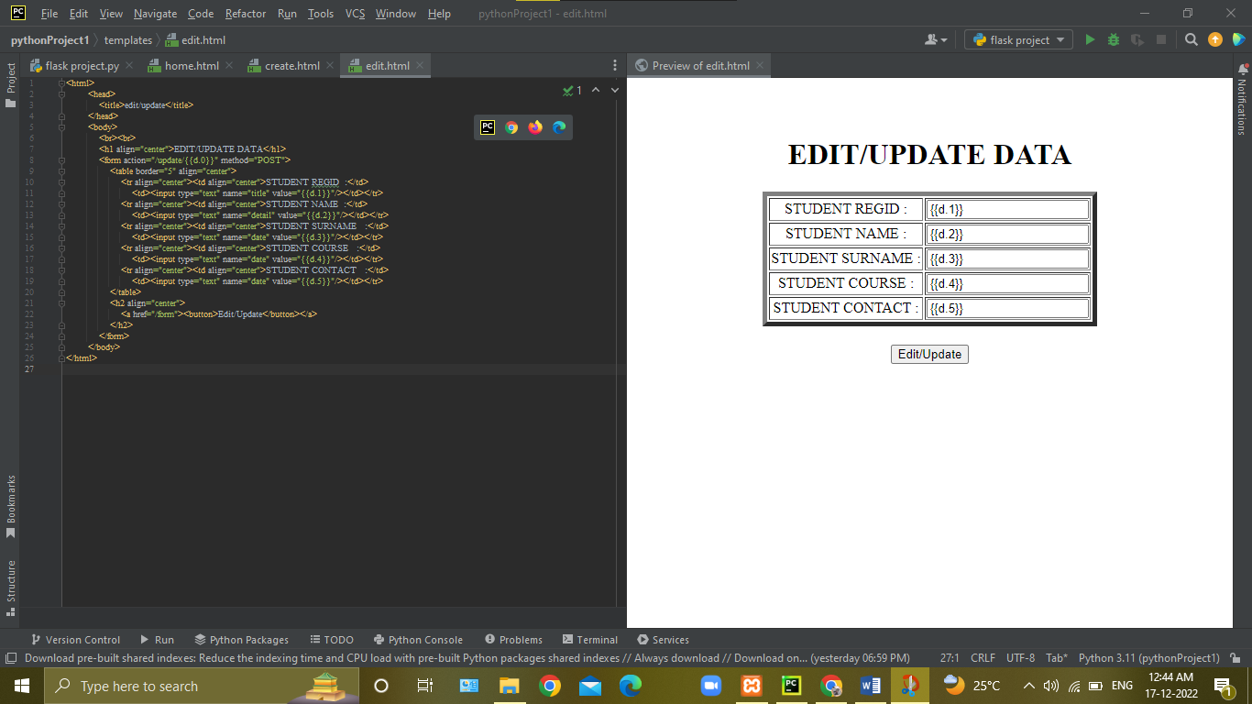

**5. OUTPUT:-**

**Program Output:-**

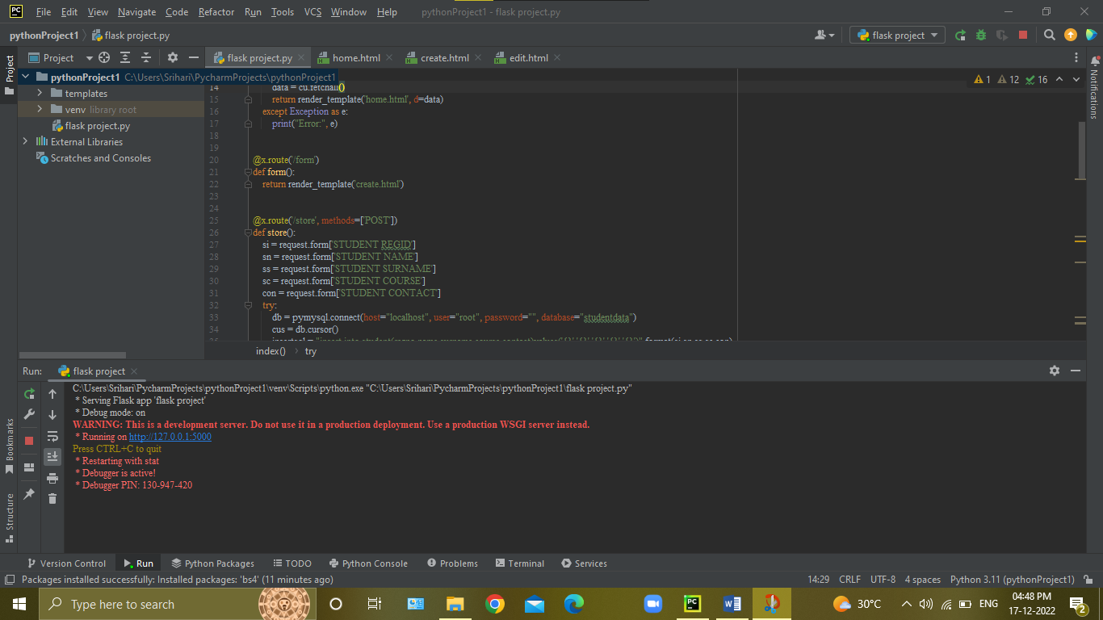

**Click to on URL or Copy URL Paste in Browser**

**HTML Home Page Output:-**

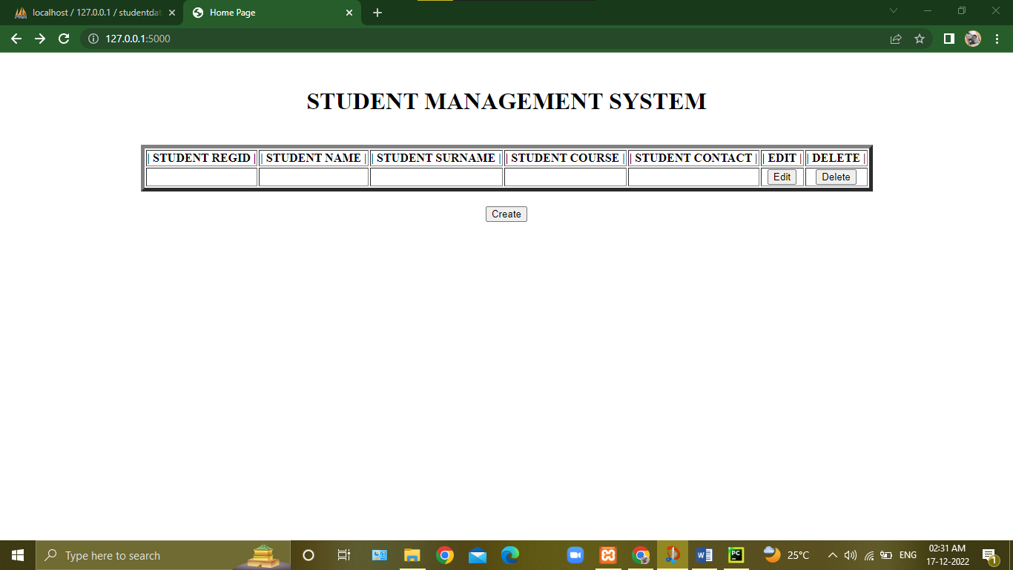

**HTML Create Page Output:-**

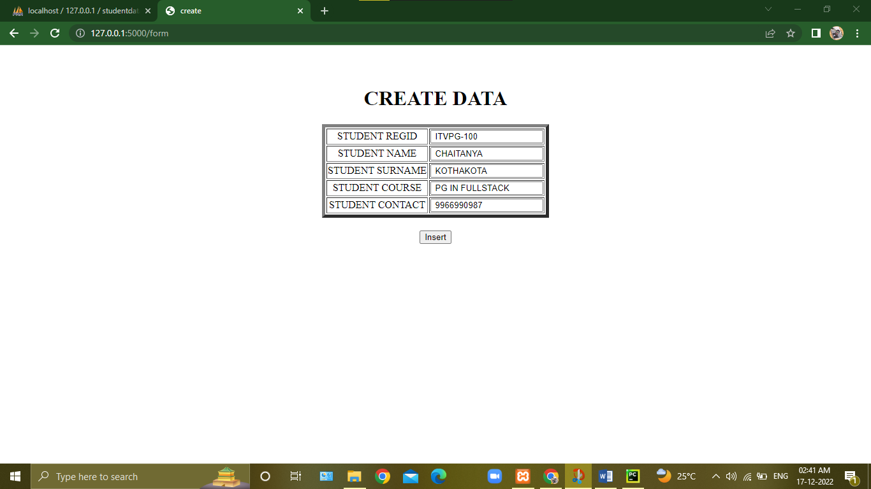

**HTML Edit/Update Page Output:-**

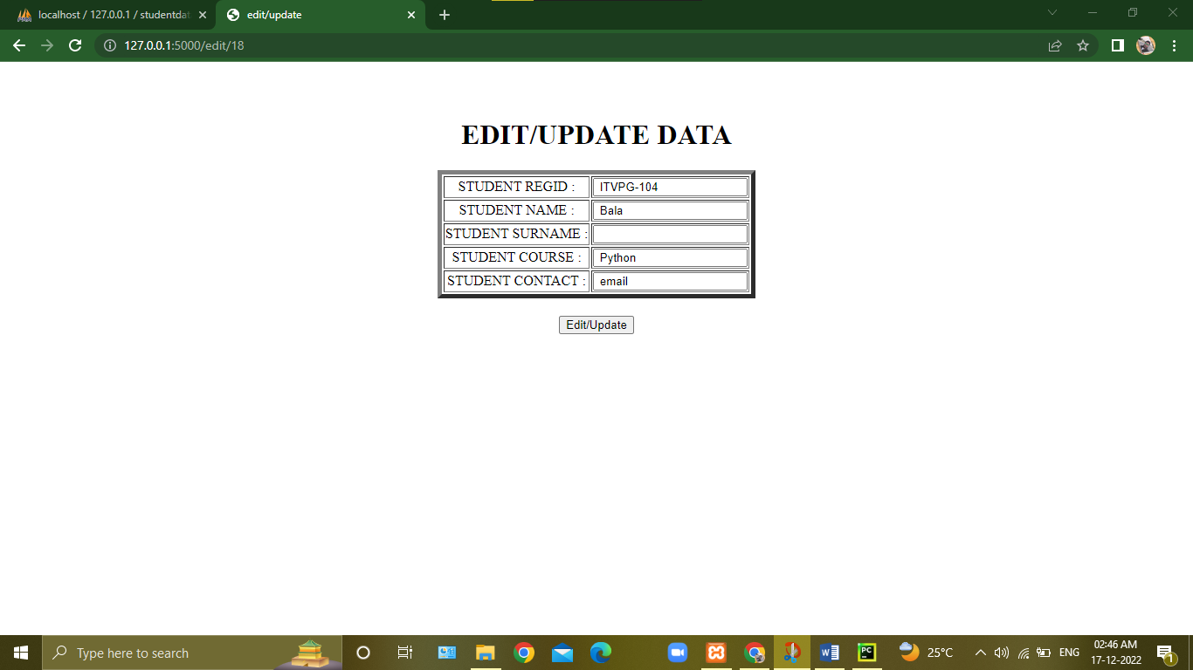

**Final Output:-**

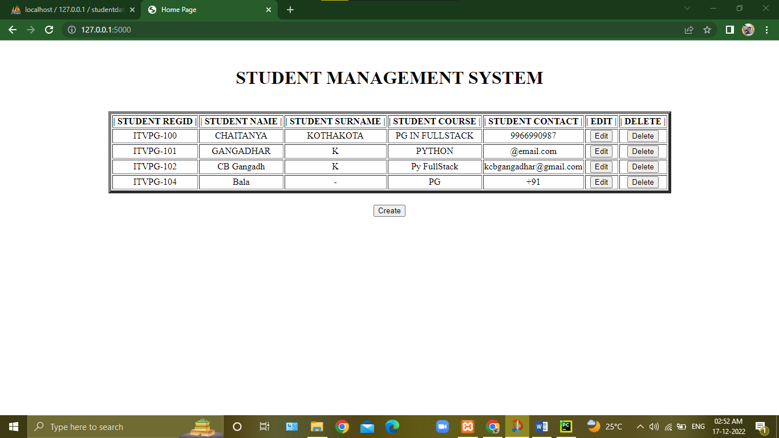

**6. RESULTS:-**

Finally I Done to Connect Python Backend to MySQL Database Using Flask Framework Create a Website Server With help of HTML Forms to Store Website Entering Data Store in Database by This Process.